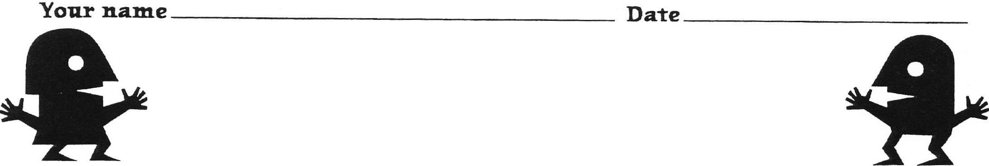

- My Best Work Habit

Complete these sentences about your best work habit.

- My best work habit is:

- This habit helps me because:

- This habit helps other people because:

(continued on next page)

KAPOW Level 1 (worksheet for "Good and Bad Work Habits and Attitudes" activity, p. 33) Lesson 3 43

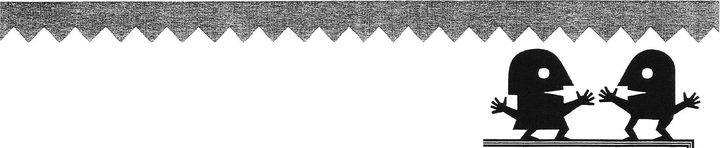Your Name
Draw a picture of yourself doing your good work habit.

Your Name Date

Opposite Day
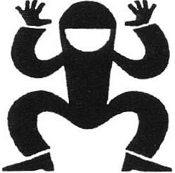

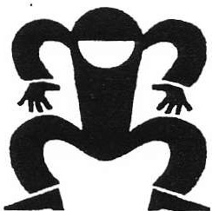

Think of a character with a good work habit. Fill in side A and draw a picture below of the character doing that good habit. What is the opposite or bad habit? Fill in side B and draw a picture below of the character doing that bad habit. (Drawings can also be done on the back or on a separate sheet of paper.)

A. NORMAL DAY

Character's name:

Good Work Habit:

(draw picture below)

B. OPPOSITE DAY

Character's name:

Bad Work Habit:

(draw picture below)

KAPOW Level 1 (worksheet for "Opposite Day" activity, p. 35) Lesson 3 45

Your Name Date
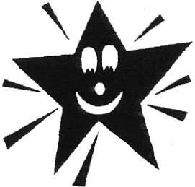

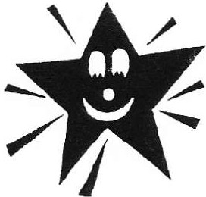

I Care

Think of someone who cares. Draw a picture of the person doing a good thing.

Write below what the person in your picture is doing:

