Date
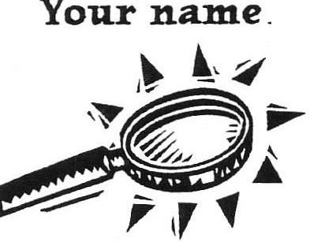



•What WILL I See? •

Before the worksite visit, make thoughtful guesses. Write your answers below each question.
- What jobs do you think you'll see on the worksite visit?

- List some needs you think those jobs will fill.

- List subjects you learn in school that you might use in jobs.

- Which work habits and attitudes will be most important?

5. List one example of a team you think you might find at the worksite.

Your name _
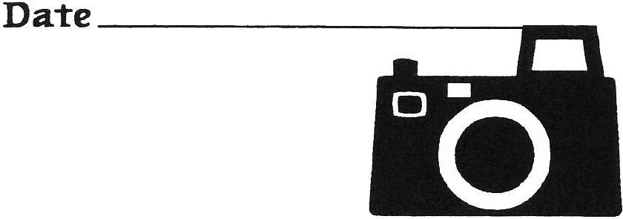

•What DID I See? •

After the worksite visit, tell what you saw. Write your answers below each question.

1. What jobs did you see?

- What needs did the jobs fill?

- List subjects you learn in school that workers used in the jobs you saw.

- Which work habits and attitudes were most important and why?

- List one example of a team that you saw at the worksite. Who was on the team and how did they work together?

- You saw many jobs at the work site. Which one do you think you would be best at and why?

Group name or number _ Date _


•Workstation Volunteer Interview •

Workstation employee's n a m e :

Workstation:

Ask an employee these questions and write the answers below each question.

1. What do you do in your job?

- What needs does your job fill in the company?

- What skills do you need to do your job?

- What did you learn in school that you use in your job today?

- What work habits are important in your job?

- Are you on a team? If yes, how many other people are on the team?

7. How do you all depend on each other?

8. If you think of other questions, write them below.

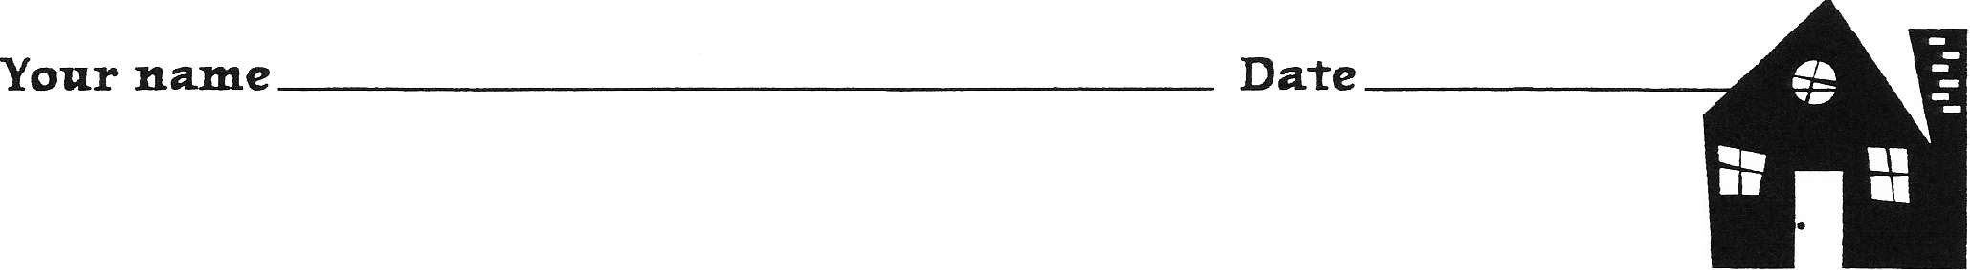

- My Worksite Visit Experience

Name of company:

Write your responses below each question. Share your answers at home with your family.

1. This is the most unusual or surprising thing I saw:

2. These are the jobs I saw:

3. The job of is important because:

4. These are some subjects I learn in school that workers use in jobs:

5. This is an example of an important work habit:

lt is important because:

6. This is an example of a team I learned about at the worksite visit:

This is how the team works together:

7. Of all the jobs I saw, I think I'd be best at this job:

This is why:

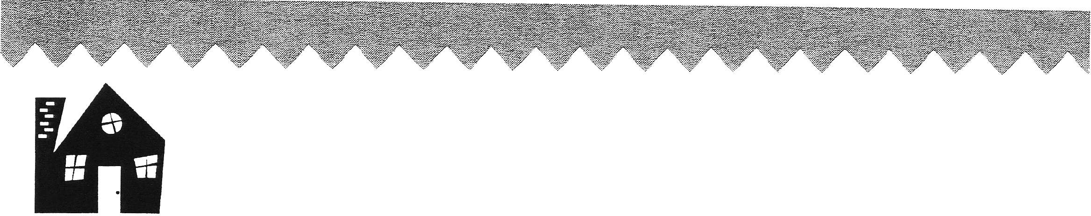
Your name Date _
•My WorksiteVisit Experience •

Name of company: _

In the space at the bottom of the page, write a paragraph about your worksite visit experience to take home and share with your family.
l. First, answer these questions: What did you do? What did you see? Who did you meet?

2. Then choose three things about the worksite visit to put in your paragraph. Here are some ideas:

► the most unusual or surprising thing
► the jobs
► why the jobs are important
► the subjects you learn in school that workers use in jobs
► important work habits or attitudes
► an example of a team
► what job you think you would be good at

Write your paragraph here:

