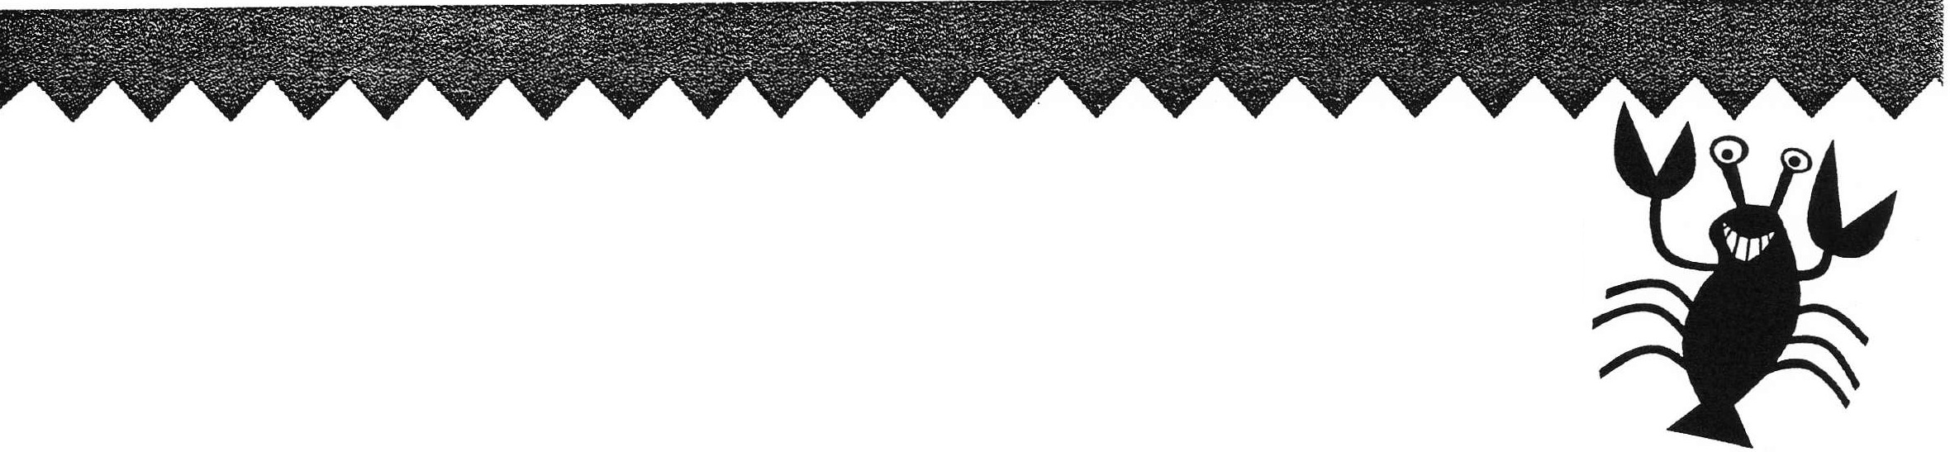

Volunteer: Choose one list of words to use. If you need more words, write them in the blanks.
Word Lists for Picture This

11 2 3 4

engine  kitchen apartment  Atlantic Ocean  rain forest  bat wolf  rocket  tractor  Saturn comet pineapple  elbow  spaghetti rose dolphin  anger  nose | driving a car  furniture neighborhood  Mediterranean  coral reef dragonfly  predator  helicopter  digging a hole solar system universe  fruit  body parts  corn on the cob bouquet jellyfish  faces | guitar player  the four seasons  camping trip  Cleopatra  4th of July Halloween  a bride's veil  the Nile River visit to Mars  good luck King Arthur and  his knights  surfing the net  a dozen donuts the North Pole  the South Pole the Equator | fast food  restaurant things you ride things youdrink  parts of  a computer  things in a kitchen things in a tool box instruments in  an orchestra  instruments in a rock band  things in a  desk drawer things with wheels  ways to  measure time  things you wear  when it's cold  things you take  to the beach

22 KAPOW Level 3 Lesson 7 (worksheet for "Picture This" activity, p. 116)

How You Say It Words
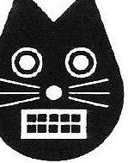

Volunteer: Write these words on separate pieces of paper OR print this page and cut out

each word.
:
' '

sweet silly

I

curious sarcastic

I angry hurt

,

' '
' '
:' :

annoyed sad

'' ''
'' ''
'' ''
:' :''
l :

happy funny

proud bored

KAPOW Level 3 (worksheet for "It's Not What You Say, It's HowYouSayIt" activity, p. 116) Lesson 7 123

“Charades” Word Choices
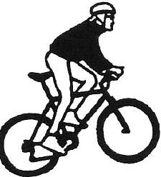

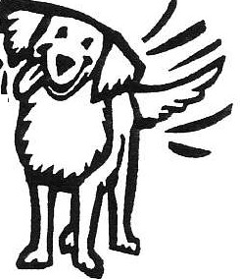

Volunteer: Print this page and cut out these words. If you need more words,
write them in the blanks.

Basketball | Horse | Love | Painting
Soccer | Alligator | Angry | Hammering
Tennis | Frog | Happy | Drinking
Golf | Dog | Sneaky | Reading
Soccer | Cat | Cold | Writing
Hockey | Snake | Hot | Hiding
Swimming | Elephant | Confused | Jumping
Lacrosse | Whale | Tired | Rolling
Baseball | Monkey | Excited | Biking
Football | Insect | Afraid | Exercising

2 4 KAPOW Level 3 Lesson 7 (worksheet for "Charades" activity, p. 117)

